Problem statement:

Perform Basic Visualizations for all the columns(numerical data only) on any

data set from data set folder make sure it has more data. So we can make better inferences for the visualizations(boxplot,histogram)

Ans: wc_at<- read.csv("wc-at.csv")

boxplot(wc_at$Waist)

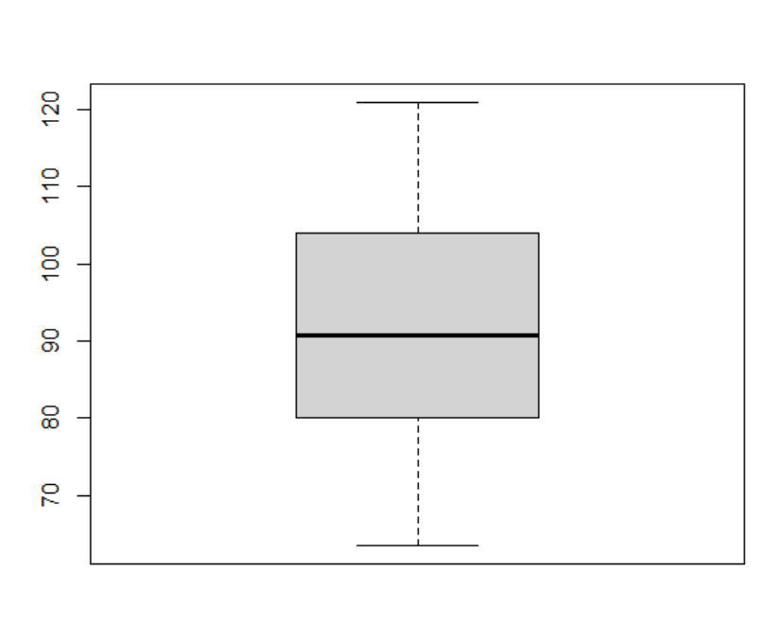

Inferences : boxplot of waist data distribution shows the data points ranges between 60 to 120 with no outliers values. IQR is almost 102-80, ie 50% of data lies between 80 – 102 almost figures. Median of the distribution is 90. More data comes after median ie, 90-105.

hist(wc_at$Waist)

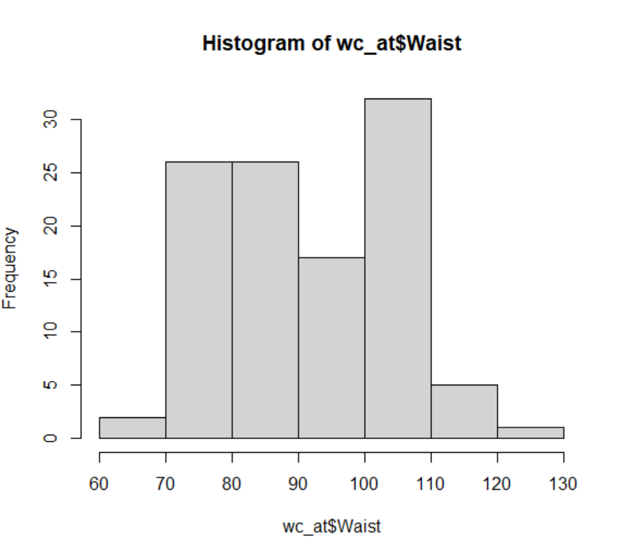

Inferences: the histogram of waist data shows the frequency of the data in the given interval. It shows most frequent values lie between 100 and 110 and both ends contain least frequent values. It is almost normally distributed. we can say a negative kurtosis present in this.

barplot(wc_at$Waist)

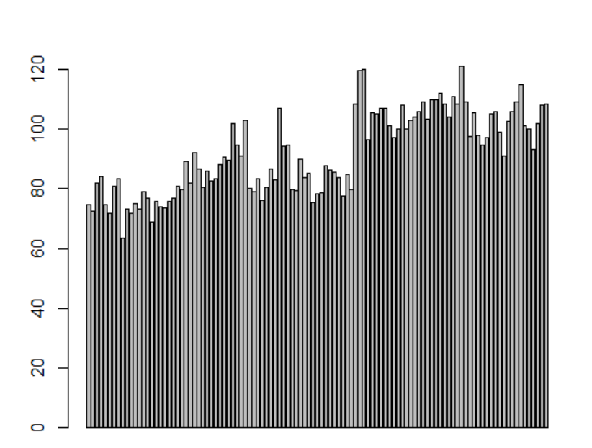

Inferences: Plotting each point in bar shape. Can understand the ranges and negative kurtosis nature of this distribution.

boxplot(wc_at$AT)

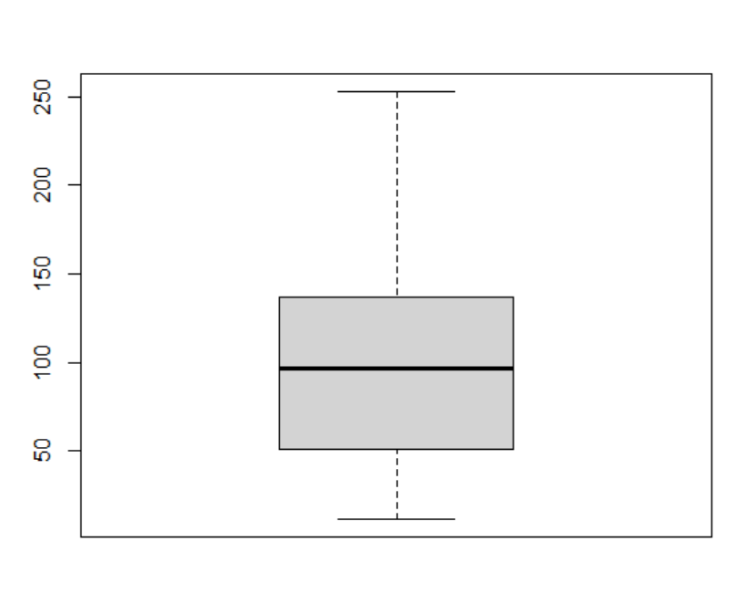

Inference: data points shown upto 250 . no outliers occur. Upper whisker value (max value ) is 250. Median is 100. There is a left skewness ie, positive skewness in the distribution. 75% of data points valued less than 150. IQR = 50

hist(wc_at$AT)

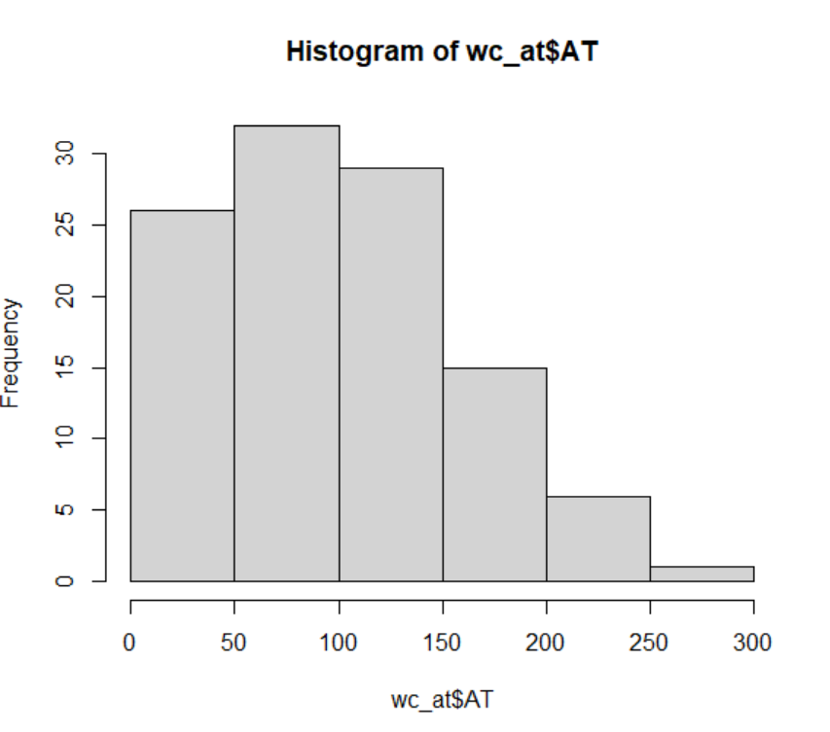

Inferences: most frequent values lie between 50 to 100, frequency up to 30.

Data is positively skewed. max value shows 300 and median can be between 100 and 150.

barplot(wc_at$AT)

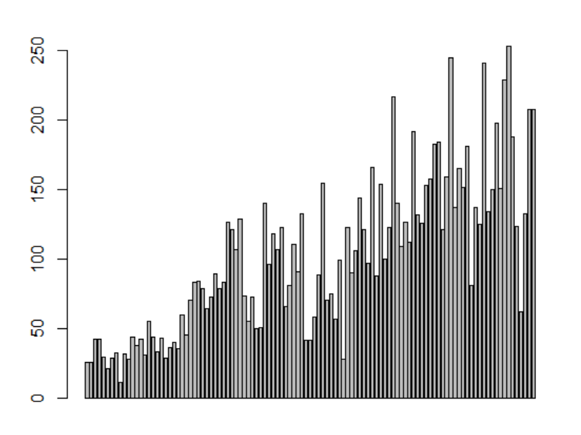

Inferences: data distribution range is shown. Normality is difficult to understand compare to histogram and box plot. Richness of data points is below 150.